USS HARWOOD DD-861 Reunion Committee SALES ITEMS
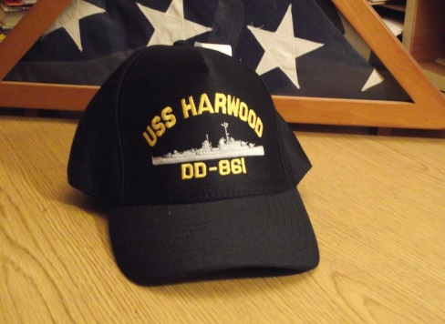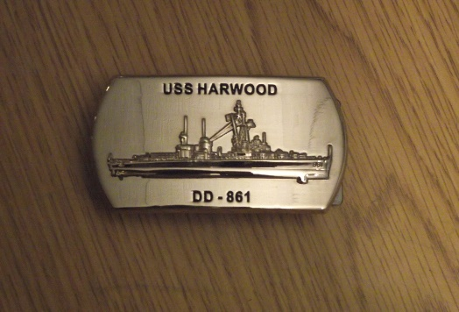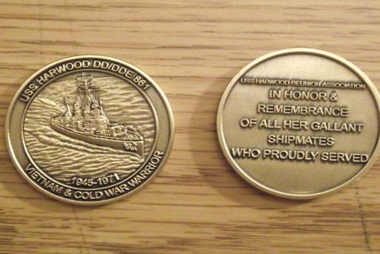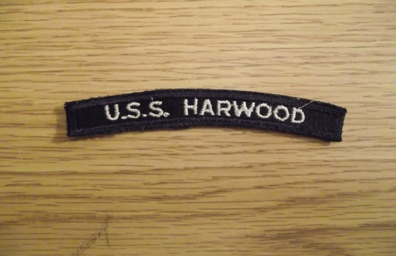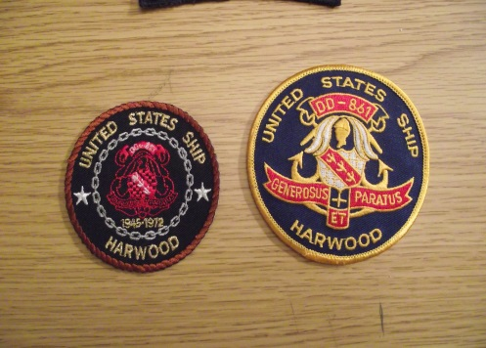 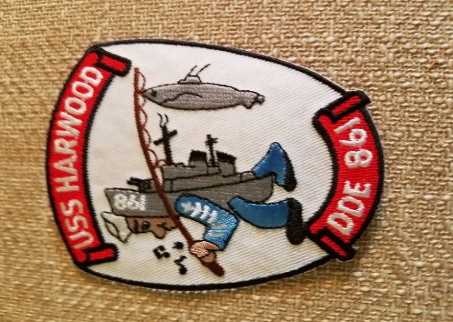 DESCRIPTION COST
- Hat INDICATE DD OR DDE (made in USA) $16.00
- Belt Buckle 3’ x 1-1/4 “ $25.00 NEW ITEM
- Coins Challenge Coin $13.00
- Unit Patch 5/8“ x 4-1/4” $3.00
- Insignia patch left photo 3” diameter $4.00
- Insignia patch right photo 3-5/8” diameter $7.00
- Insignia patch Shield patch 3” x 3-3/4” h DDE-861 $7.00 NEW ITEM
- Bumper sticker 3” x 9” self-adhesive (two) $1.00
(NOTE: THIS IS THE ONLY OFFICIAL USS HARWOOD SALES SITE, ALL OTHERS ARE COMMERCIAL)
SHIPPING FOR ITEMS 1,2, & 3 is $7. NOTE: IF ITEMS FROM BOTH GROUPS ARE ORDERED
SHIPPING FOR ITEMS 5 THRU 8 IS $2.00 AT THE SAME TIME TOTAL SHIPPING IS $8.00.
Items requested
N0. Item cost name________________________________________
____ _________________ _______ address_____________________________________
____ _________________ _______ city,st. ________________________ zip__________
____ ___________ _____ _______ MAKE CHECKS OUT TO:
Shipping _______ USS HARWOOD REUNION COMMITTEE & MAIL TO
Total ________ Anthony Accatatta
11438 PERICO ISLE CIRCLE
BRADENTON, FL. 34209

